Introduction

On September 12, 2025, an educational trip was organized by our university to Sajek Valley, which is called the Queen of Hills of Bangladesh. The beauty of nature, the thrill of the mountain streets, and the time spent with classmates were all memorable trips. But for me this trip was not just a trip; It was a journey of learning, observation and feeling. About eighty of us teachers and students left together on the way to Rangamati and Sajek. Mountain crooked roads, rain-soaked clouds, Kanglak hilltops, and the roar of springs. The whole journey has made me understand that law is not just the sound of books, it is a part of life. Carelessness of cars on hilly roads, risky movement, or environmental neglect have all made me think about responsibility, awareness and the legal value of humanitarian care.

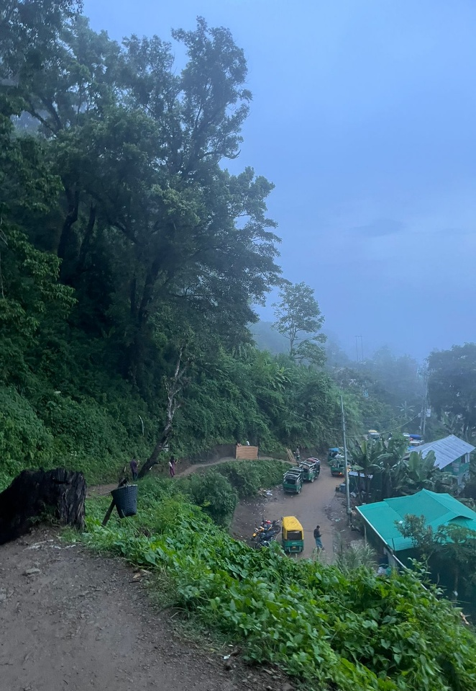
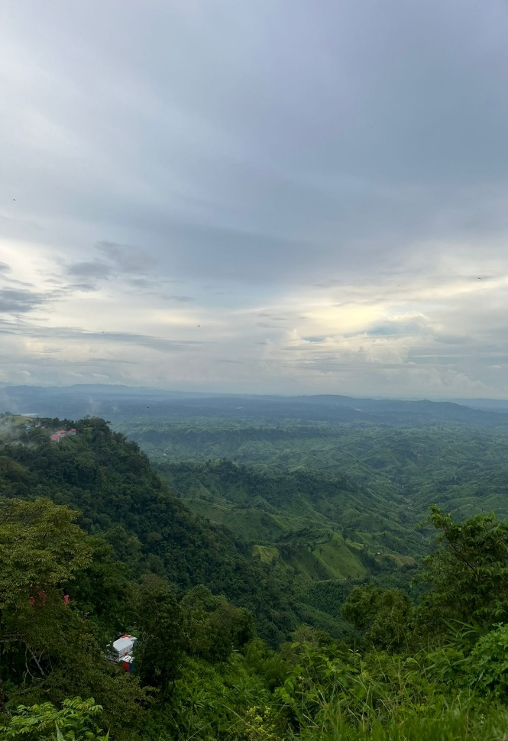
Brief Overview of the Field Visit

Locations
Khagrachari District
Location: Chittagong Hill Tracts, Southeast Bangladesh. It is one of the three districts of Chittagong Hill Tracts (along with Rangamati and Bandarban). It is called “Hills City” or “Fountain State” for its mountains, fountains and natural beauty.

Sajek Valley
Location: Baghaichhari Upazila, Rangamati District, Chittagong Division

1. Helipad View Point (Helipad View Point)
Ruilui Para, Sajek Union, Baghaichhari Upazila
An open space located at the highest point in Sajek.From here clouds, mountains, sunrise and sunset can be seen together.Also known as the main tourist center of Sajek. 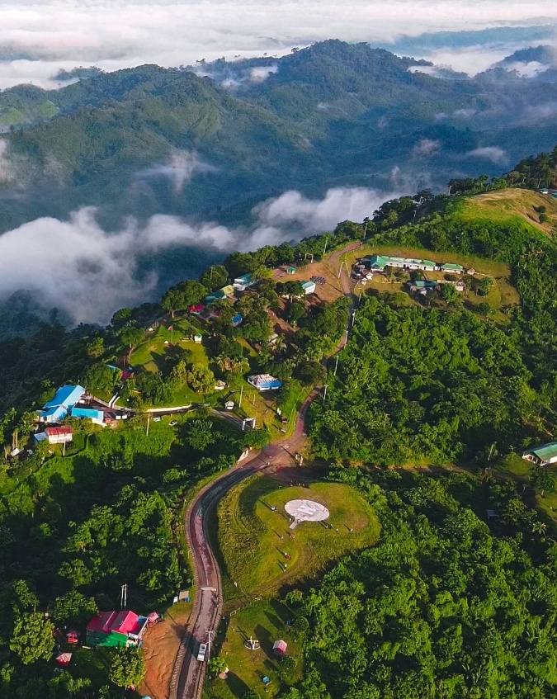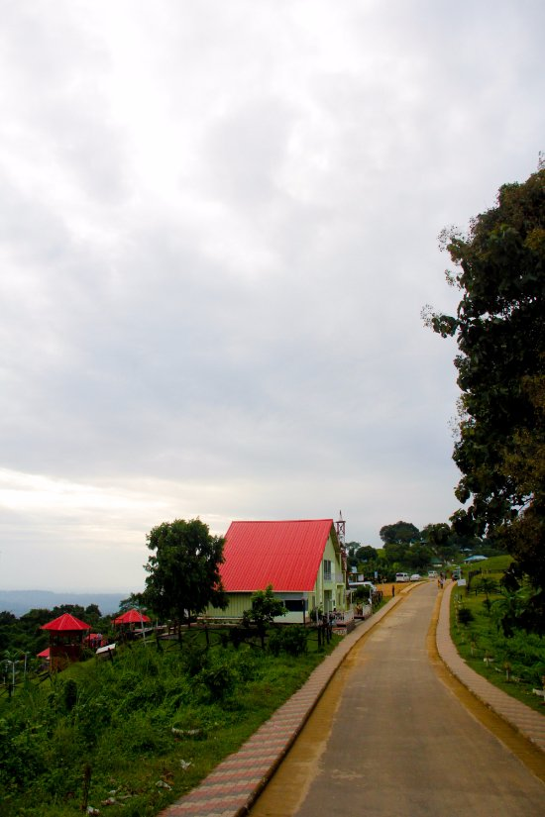
2. Kamalak Hill (Kamalak Hill)
Areas adjacent to Kanglak Para, Sajek Union, Baghaichhari Upazila.One of the most beautiful hills in Sajek.From here the entire Sajek valley can be seen.The morning cloud-covered view is very charming.
3. Ruilui neighborhood (Ruilui Para)
Sajek Union, Baghaichhari Upazila
The oldest Lusai indigenous village in Sajek.
The culture, clothing and traditions of the locals can be seen directly here.
4. Kanglak neighborhood (Konglak Para)
Sajek Union, adjacent to Mizoram border in India
The highest and last village of Sajek.Indian hills can be seen from here.Tourist favorite place for sunset.
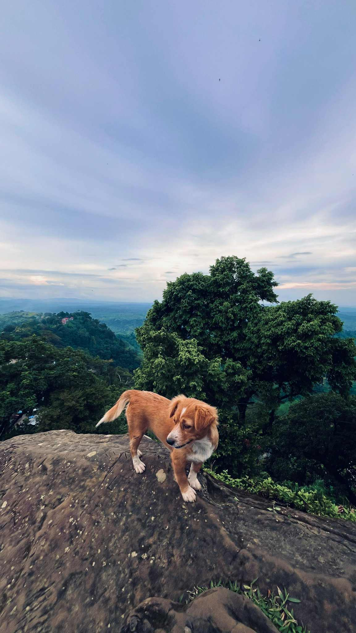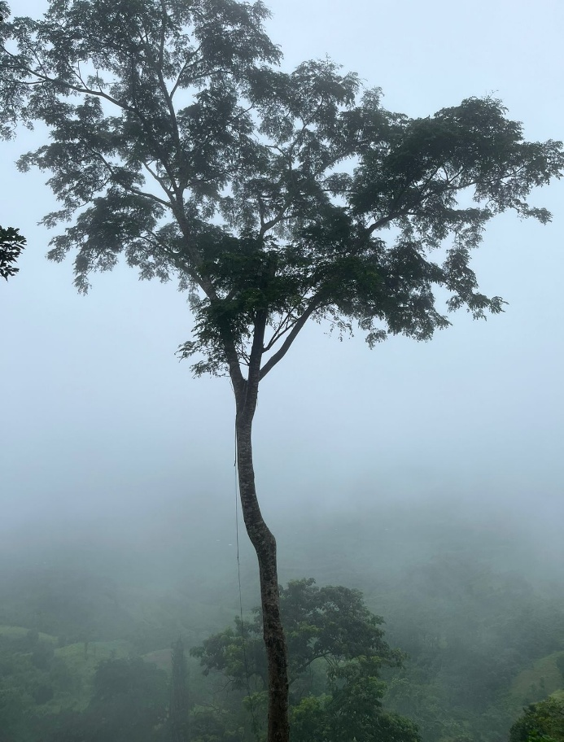

Rangamati District
Location: Chittagong Hill Tracts, Southeast Bangladesh
1. Kaptai Lake (Kaptai Lake)
Kaptai Upazila, Rangamati District.The largest artificial lake in Bangladesh.It was built in 1960 during the construction of Kaptai Dam.The most popular place for boating.
2. Suvlong Shower (Shuvolong Waterfall)
Barkal Upazila, Rangamati District
Located about 25 km from Rangamati city.Kaptai Lake can be reached by boat midway.The beauty of the shower is most enjoyable in monsoon.
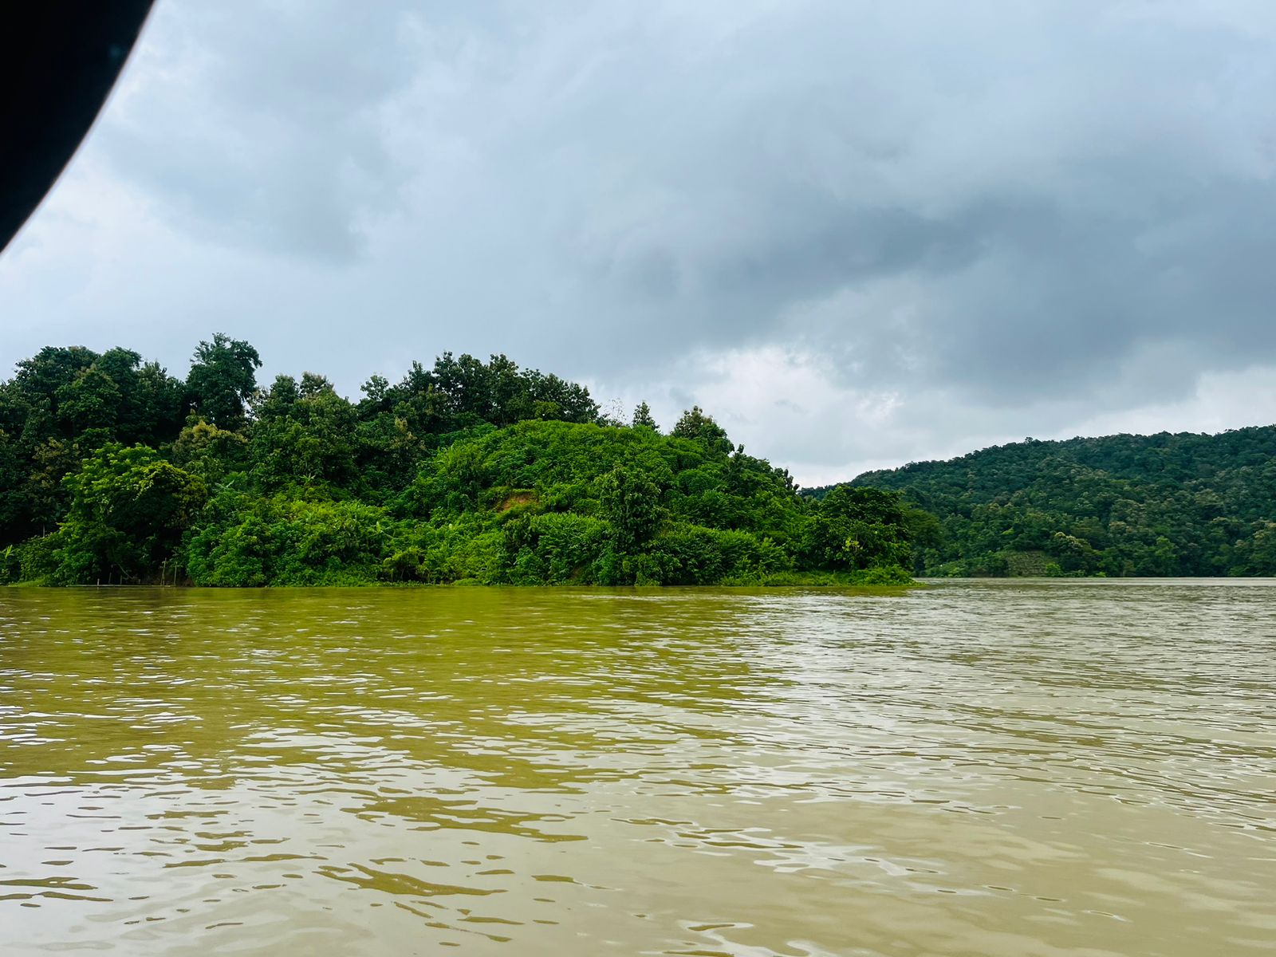
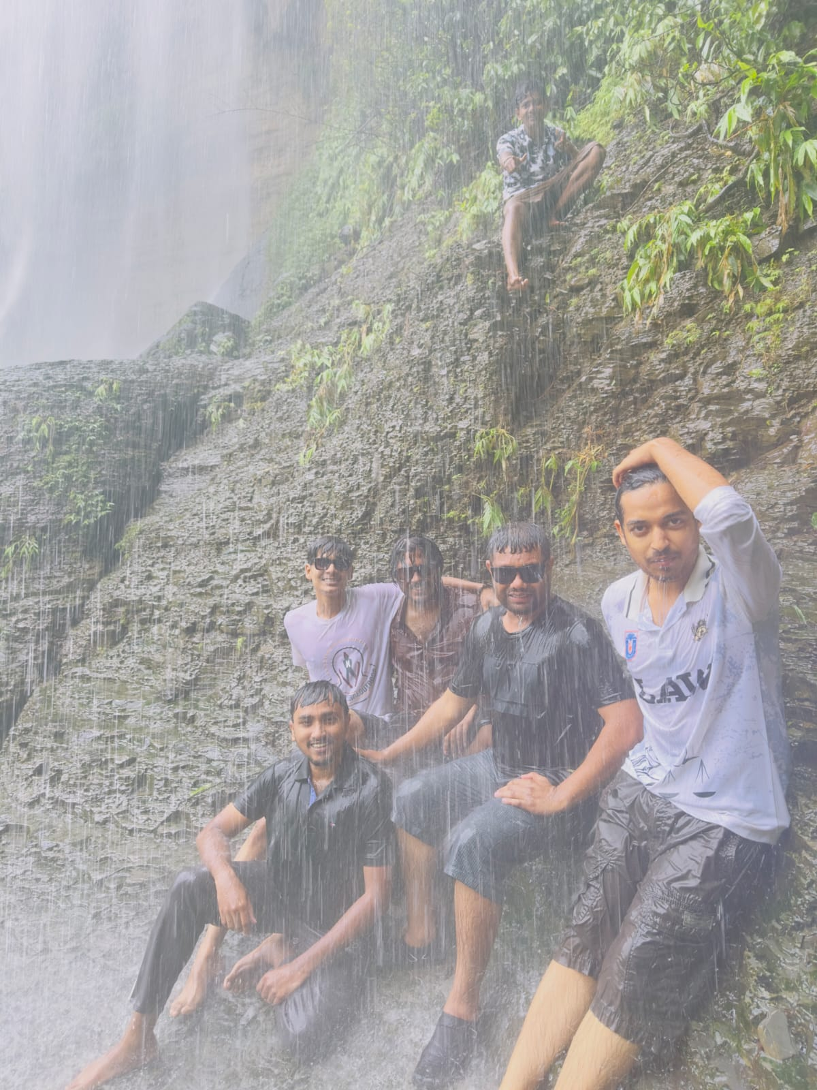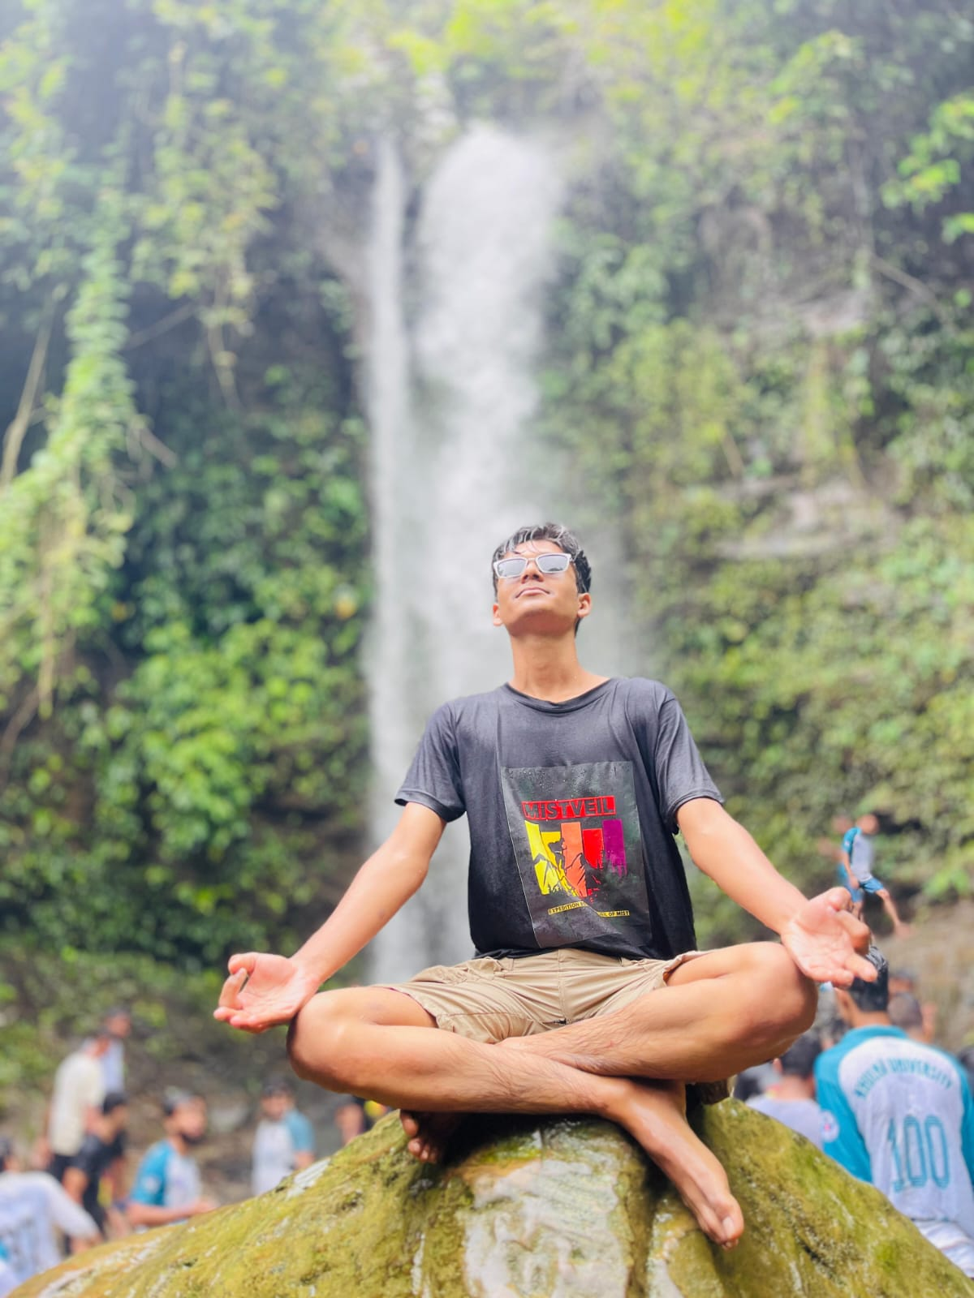

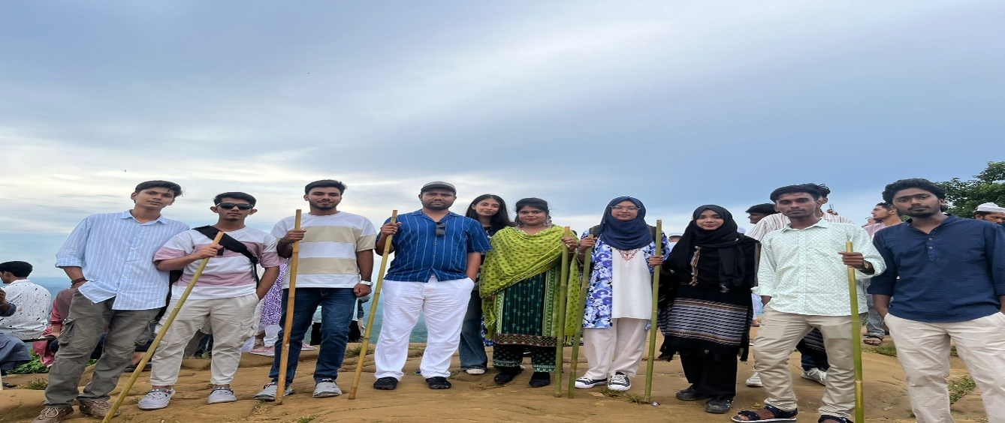
With our respected tort law teacher
Purpose of the visit

As I learned on this tour, Tort Law’ (Tort Law) is not just a court topic; It lives within every small and big event of daily life. When people neglect to harm others, or fail to take responsibility for security, the relevance of tort lo’ comes to the fore. Behind the beauty of Sajek Valley, we also find mismanagement, insecurity, and indifference to the environment. On September 12, 2025, an educational trip was organized by our university to Sajek Valley, which is called the Queen of Hills of Bangladesh.
The beauty of nature, the thrill of the mountain streets, and the time spent with classmates were all memorable trips. But for me this trip was not just a trip; It was a journey of learning, observation and feeling. About eighty of us teachers and students left together on the way to Rangamati and Sajek. Mountain crooked roads, rain-soaked clouds, Kanglak hilltops, and the roar of springs.
The whole journey has made me understand that law is not just the sound of books, it is a part of life. Carelessness of cars on hilly roads, risky movement, or environmental neglect have all made me think about responsibility, awareness and the legal value of humanitarian care.

Journey overview

We left for Sajek Valley on September 12, 2025 from the Law Discipline of Khulna University. Everyone was asked to be present at the discipline at around 5:30 pm, and our bus left at around 6 pm. There were about 80 teachers and students in total. Many from batches 21 to 25 participated in this tour.
As the night fell, we took a break in Comilla. After resting for a while and eating, we set off again for Rangamati. In the morning, after reaching Rangamati, we had breakfast and prepared to go to Sajek. An open-top car called “Chander Gari” was rented to go to Sajek. We were lucky to get a good car, so the journey was quite enjoyable. There are two types of Chander Gari in Rangamati, one white and the rest are green or red, the white ones are considered to be a bit better car. The hilly roads, the wind and the excitement of a new place - all of them were working in a different way for everyone.

‎After reaching the hotel, we went for a walk in the helipad area of Sajek in the afternoon. From there, the entire Sajek Valley can be seen. The scene covered in afternoon clouds was a sight for everyone. This is how our first day passed amidst various busyness and joy. On this day, we had a lot of fun with our senior brothers and sisters and junior's younger siblings, as well as some great teachers. Our first day was over.

‎On September 13, i.e. the second day, in the morning, we went to see the Kanglak waterfall. It was raining heavily that morning, so the road was very slippery and risky. Still, we set off with some risk and excitement in our hearts. After walking on the hilly path for about 45 minutes, we reached the waterfall. The place was beautiful, but the road to and from was dangerous. This terrible road was as slippery as it was winding and there were huge ravines all around. Once you slip in this ravine, you have to choose again. However, when we reached the waterfall, we forgot all the fatigue and hard work by seeing the beautiful beauty of the waterfall. After returning, we rested in the afternoon and went to Kanglak Hill in the afternoon. Which was the highest hill in Sajek, the entire Sajek can be seen from this hill. Due to the rain, the mountain road was even more muddy and slippery. The weather was cold, and there were only clouds and fog around. It felt like we had somehow crossed into the kingdom of clouds.

‎
‎On the morning of September 14, we went from Sajek to Rangamati. Then from there we left for Bandarban. On the way, we came across a place called Alutila. It was not in our tour guide, but we went there after the afternoon. Usually, going to Alutila after the afternoon is prohibited, because the place is dark and mountainous. Even then, we turned around for a while and left.

‎On the way back, it was evening, and then the army stopped our bus on the way to Bandarban. They said that it was not safe to go on this road at night. They also instructed us that there could be robbers here and that a band of robbers could suddenly block the road and attack the bus. Still, our teachers took permission and started the journey slowly. At times, the road was dark and silent, but in the end, we reached Bandarban safely.

‎The next day, September 15, in the morning, we went to Kaptai Lake. Kaptai was a huge man-made beauty. A wonderful lake surrounded by mountains. After spending the whole day on a boat, taking pictures and enjoying nature, we left for Khulna in the afternoon. The next morning, our tour ended with our arrival at Khulna University.

‎This entire tour was a lot of experience. We traveled in the mountains, walked in the rain and mud, and helped each other even on risky paths. We saw, learned and understood a lot. It was not just a tour, but a place to learn how to work together, make decisions and handle situations in real life.

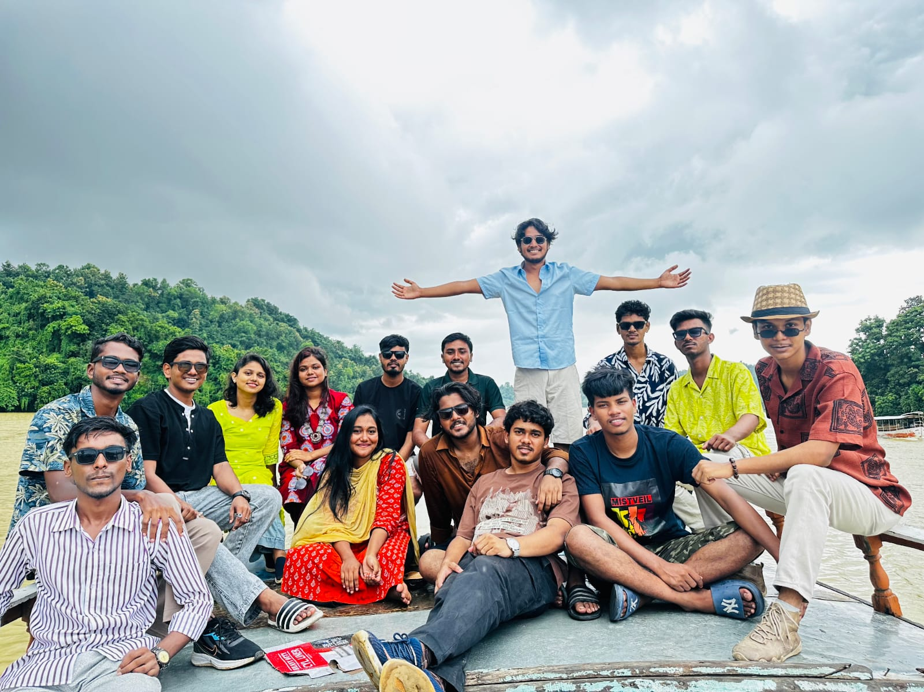

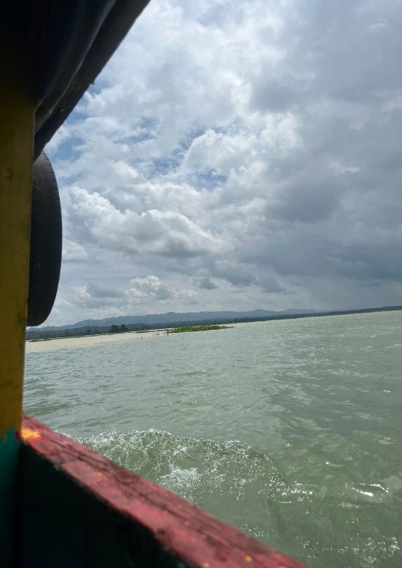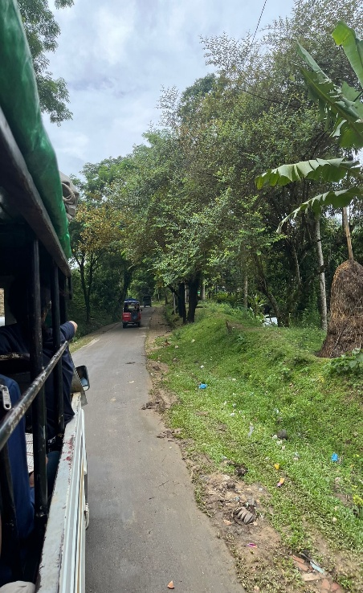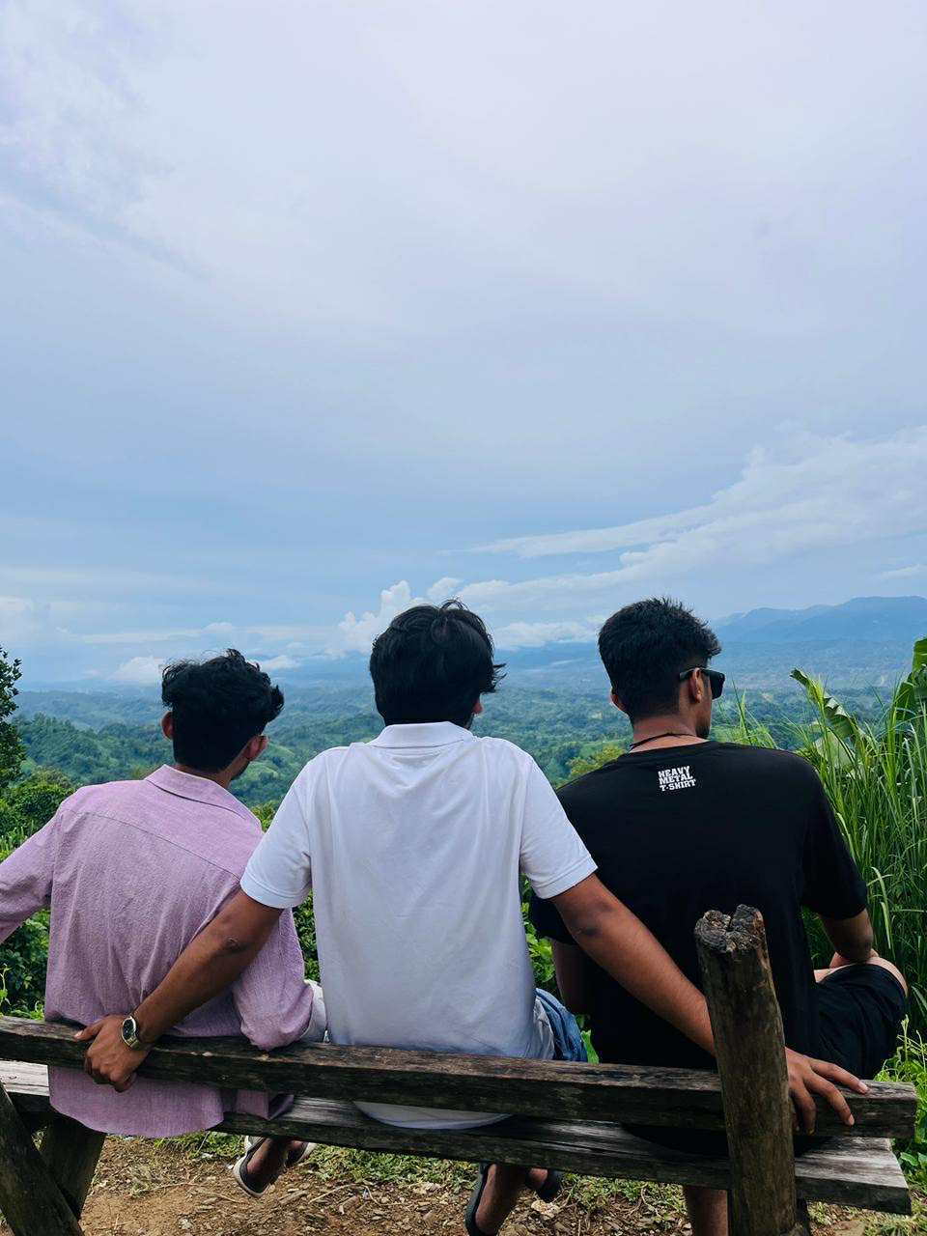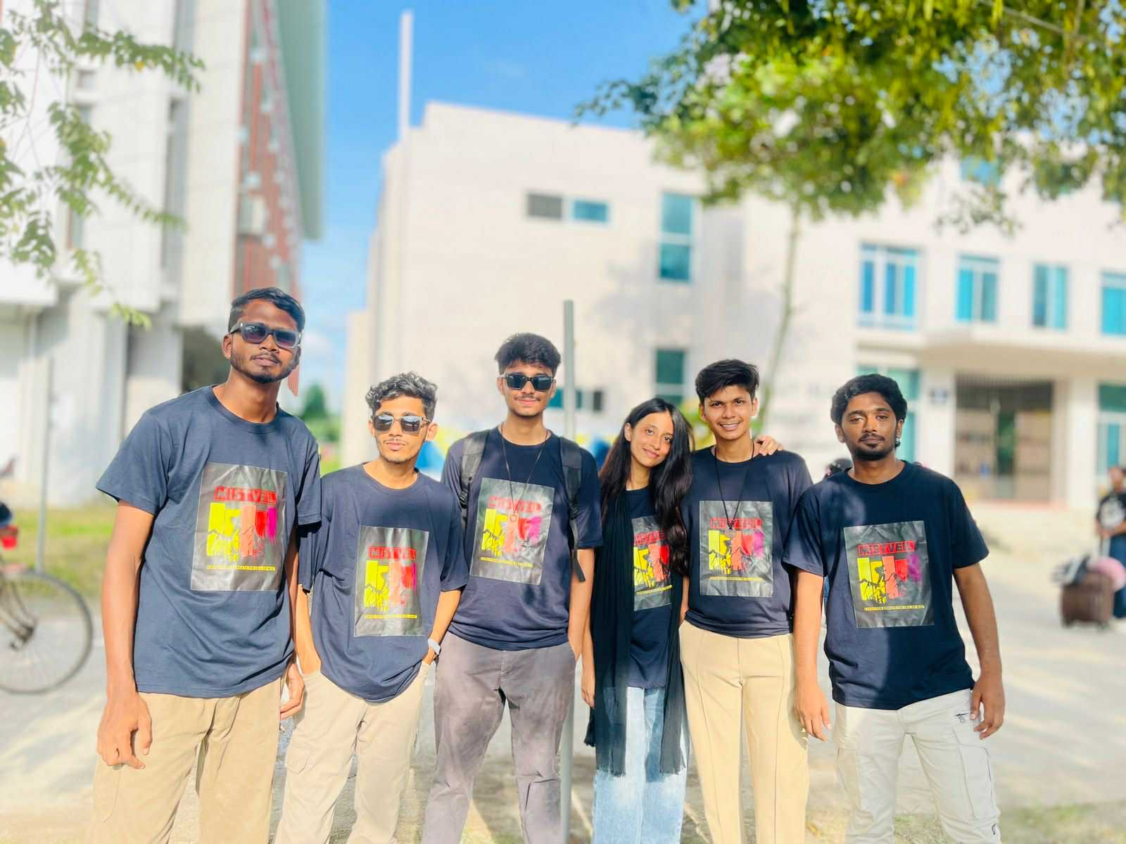

Tortious Acts Observed during the tour

We observed many real events and behaviors during the field trip, which, from the point of view of tort law, it is clear that these activities include negligence, carelessness, environmental or social disturbance, and failure to perform legal duties. Although most of these activities were not intentional, they could still be considered tortious acts or civil injustices in the eyes of the law, as they are capable of negatively impacting someone else’s rights or safety.

Incident Description

A very tragic accident occurred On September 17, 2025. Rubina Afsana Rinki, a student of Physics Department (Batch 21) of our university died in a university trip to Sajek Valley. A jeep carrying students lost control while coming down the hill and fell into a roadside ditch in Baghaichhari upazila area of Rangamati. Rinki died on the spot in the accident and 12 other students who were with her were injured, three of whom were in critical condition.
The Students were traveling to Sajek Valley as part of a university trip. According to reports, the driver lost control of the steering wheel while coming down the steep slope which caused a fatal accident.
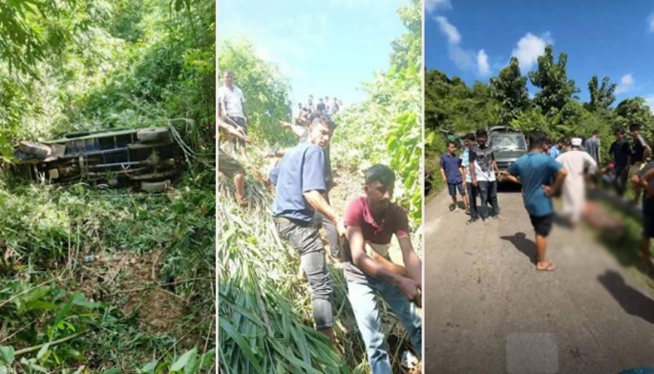

Torts arising from the accident

On the way to Sajek, Physics 21 batch girls were riding in green Chand’s car. The green cars were old; fitness was not good either. As the car was climbing up the high slope, it suddenly lost balance by failing the brakes. At this moment the driver jumps out to save his life, and the car falls into a ditch.

Negligence

Definition: Negligence is a condition where one does not take proper precautions even after realizing the possibility of harming another. Simply put, “is not to be careful and harm others.
In this accident Negligence becomes apparent. The owner or driver of the vehicle knew or should have known that the vehicle was not safe. Yet they let the car drive. This is direct negligence: endangering passengers due to lack of vigilance.

Vicarious Liability

Definition: Vicarious Liability is by law, when one has not directly neglected oneself, yet one is responsible for the mistakes made by his employee or representative while working.
In this accident, Vicarious Liability became associated with the incident because of the owner. The driver was driving for the owner. The owner would be liable in the eyes of the law for the negligence of the driver, as the driver was working while on the job. That is, not only the driver but also the owner will be responsible for the danger and damage to the passengers.

Incident Description
When we went to Shublong Jharna in Rangamati, we were all trying to climb the rock. The teacher clearly said it cannot be done, because it is dangerous. Still some disobeyed the teacher's orders and climbed on the stone. One of them was injured.

Torts arising from the accident

Negligence
The main thing here in terms of tort is Negligence. Those who disobeyed the order ignored their responsibility to ensure their own safety and the safety of others. So their negligence caused the injury. It will be treated as direct negligence

No Vicarious Liability
Here teachers will not be directly responsible, as they have given direct instructions and prevented attempts.
Therefore, Vicarious Liability does not apply to the owner or teacher.

Incident details:

It is forbidden to go to Bandarban after evening from Alutila. When we got there Army stopped us and said it was dangerous. Still, we disobeyed them and went there.

Torts arising from the accident

Negligence
Basically, what is shown is our own negligence. We have disobeyed the warning order (going beyond safe time). This has increased our own risk.
So direct negligence here means not fulfilling our own responsibilities.

No Vicarious Liability
Army or anyone else is not directly responsible here. They warned. There is danger due to our negligence, so responsibility cannot be imposed on others.

Incident Description

A classmate lost his mobile during the tour. He wrongly complains to another of your classmates that he stole the mobile. This allegation spread to others and tarnished the reputation of the classmate. It was later found that the mobile was actually lost, not stolen.

Torts arising from the accident
Defamation
False allegations were made against the classmate which tarnished his reputation. It is Slander, because the word was spoken orally.
Material
- False conversation or complaint.
- Disclosure to third parties.
Conclusion

This tour gave me a unique, exciting, and educational experience. The various incidents that occurred along the Sajek Valley journey—such as negligence, irresponsibility, carelessness, and defamation—helped me to deeply understand that law is not just a book; it is closely related to our daily lives. The death of my sister, a Physics 21 batch student, especially moved me deeply. This incident taught me that a slight carelessness or negligence can sometimes cause a fatal accident. This realization made me more thoughtful. Other incidents on the trip also showed me how irresponsible or wrongful behaviour can harm the rights and dignity of others.
This experience not only taught me practical lessons in tort law, but also taught me to be more aware, responsible, and humane. I now realize that tort law does not just teach us justice—it builds a solid foundation of safety, mutual respect, and morality in society. I believe that this experience will serve as a profound inspiration and guidance in my future academic career and legal career.

Reference
Sarder miad bin mahmud , Naimul islam mubin , Mehedi hasan plabon

